# Accessing SAR Data

## Objectives

By the end of this exercise, you will be able to:

* Identify a subsection of a SAR image or create a mosaic
* Preprocess a SAR image
  + Perform radiometric and geometric calibrations
  + Reduce speckle
* Process a SAR image through an index, supervised or non-supervised approach

## Outline

1. Sentinel 1 Background
2. Accessing, Opening, and Displaying the Data
3. Preprocessing
4. Analysis

## Part 1: Sentinel 1 Background

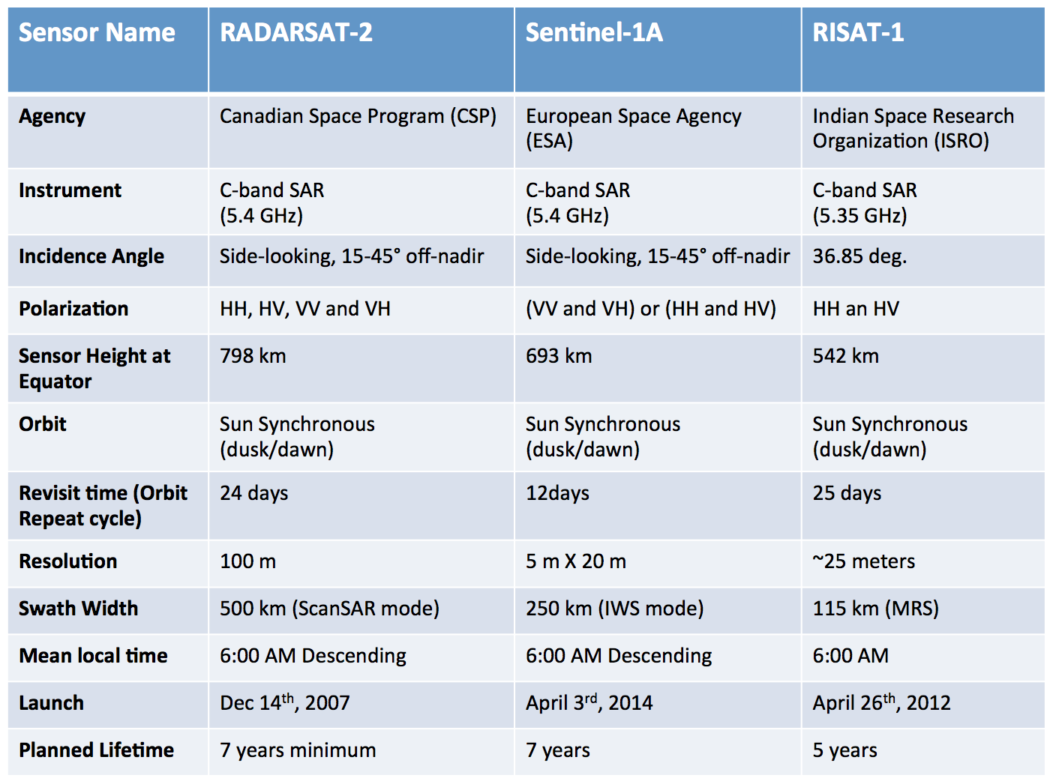

**Coverage**

* Sentinel 1 consists of two satellites: A and B
* Each satellite has global coverage every 12 days
* Global coverage of six days over the equator when using data from both satellites

**Modes of Acquisition**

* Extra Wide Swath: for monitoring oceans and coasts
* Strip Mode: by special order only and intended for special needs
* Wave Mode: routine collection for the ocean
* ****Interferometric Wide Swath: routine collection for land

**Accessing Sentinel-1 Imagery**

* Alaska SAR Facility: <http://www.asf.alaska.edu/sentinel/>
* European Space Agency (ESA) Portal: <http://earth.esa.int/web/guest/home>

**File Naming Format**



In the file naming system, there are three types of product types: SLC, GND, and OCN.

* SLC: Single Look Complex
* GND: Ground Range Detected (select this one)
  + GRD products can be in one of three resolutions:
    - Full Resolution (FR)
    - High Resolution (HR)
    - Medium Resolution (MR)

Resolution is dependent upon the amount of multi-looking performed. Level-1 GRD products are available in MR and HR for IW and EW modes, MR for WV mode and MR, HR and FR for SM mode.

**Sentinel-1 Toolbox**

An open source software developed by ESA for processing and analyzing radar images from different satellites. It includes:

* Calibration
* Speckle Noise
* Terrain Correction
* Mosaic Production
* Polarimetry
* Interferometry
* Classification

## Part 2: Accessing, Opening, and Displaying the Data

* Go to the Alaska Satellite Facility Sentinel Data Portal:
* <https://vertex.daac.asf.alaska.edu/>
* Identify your area (-60.31,-4.52,-57.81,-4.52,-57.81,-2.92,-60.31,-2.92,-60.31,-4.52) and dates of interest (Apr. 25-29, 2015)
* Identify images of interest (Sentinel-1 A/B)
* Click on **Search**
* Select granule S1A_IW_GRDH_1SDV_20150428T093856_20150428T093921_005682_0074A1_D968
* 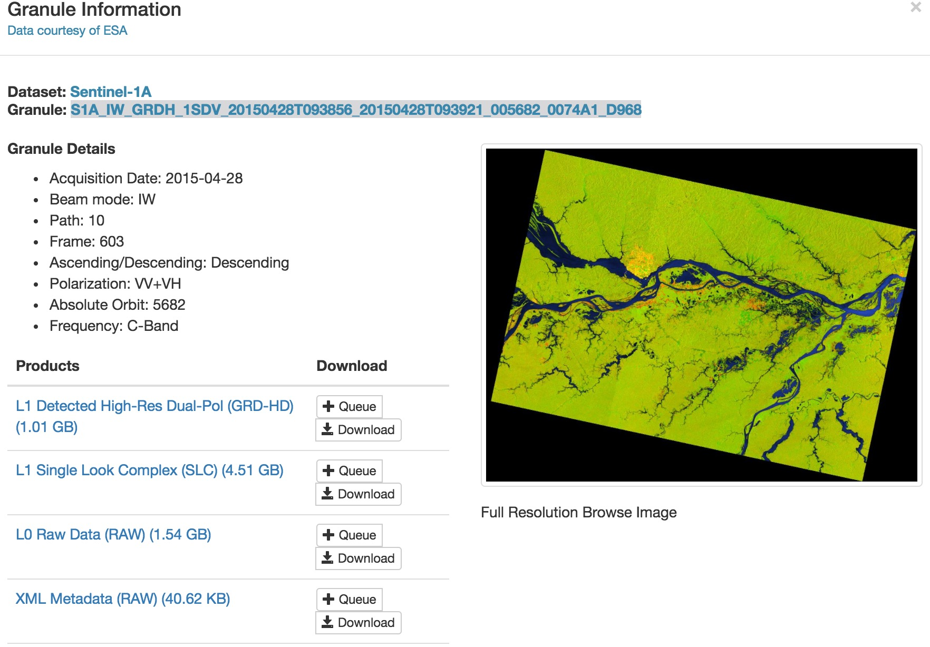Download the L1 Detected High-Res Dual-Pol (GRD-HD) Product
* Open the data with the Sentinel Toolbox
  + Initiate the Sentinel Toolbox by clicking on the its desktop icon
  + In the SNAP interface, go to the **File** menu and select **Open Product**
  + Select the folder that contains your Sentinel-1 data, and double click on the **.zip** file (do not extract files from the .zip file; the program will do that for you)
* The **Product Explorer** window of the Sentinel Toolbox contains your file. Highlight the filename and double click on it to view the directories within the file, which contains information relevant to the image, including:

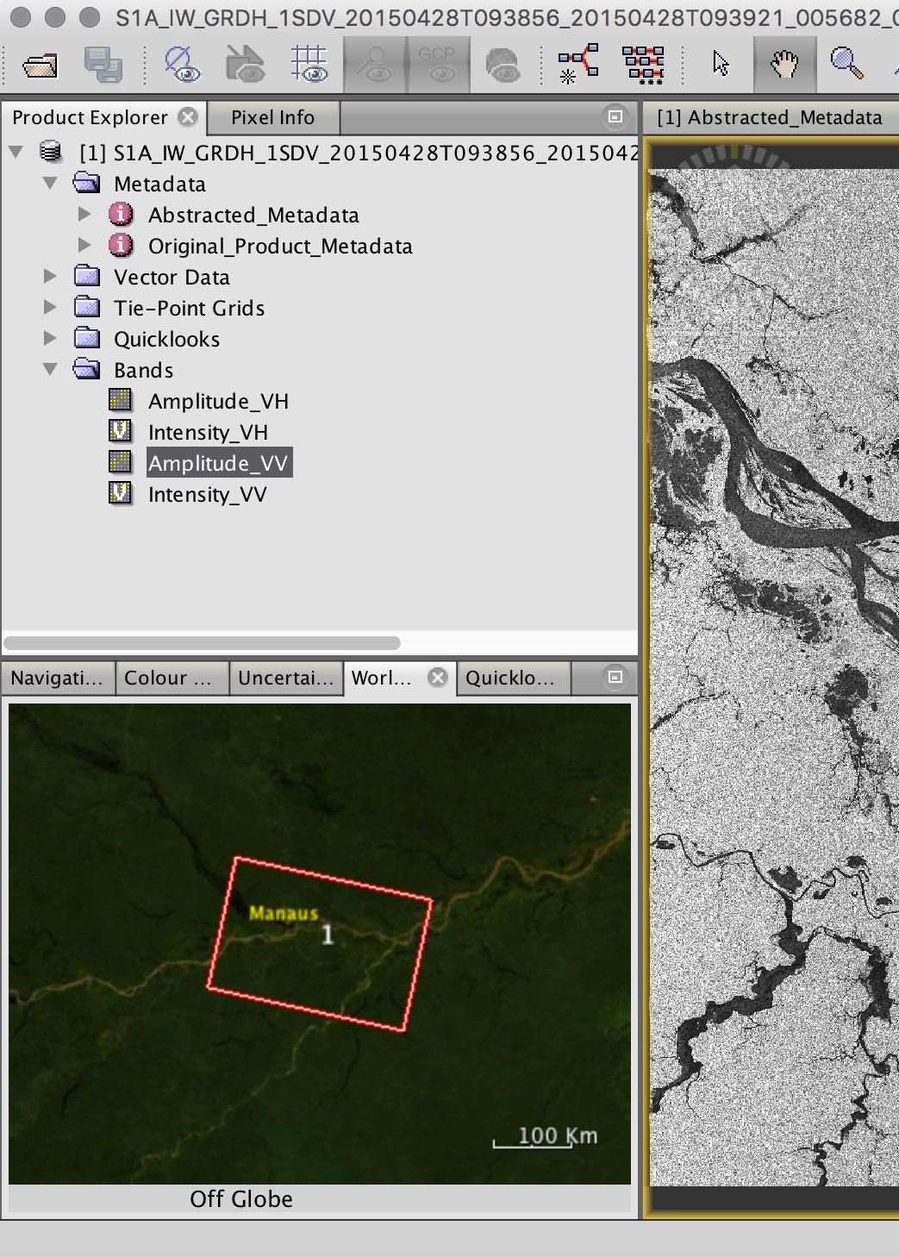

* + **Metadata**: different parameters related to the orbit and data
  + **Tie Point Grids**: interpolation of latitude/longitude, incidence angle, etc.
  + **Bands**: within the file
* There are two bands for each polarization: intensity and amplitude
  + Intensity is the amplitude squared
* 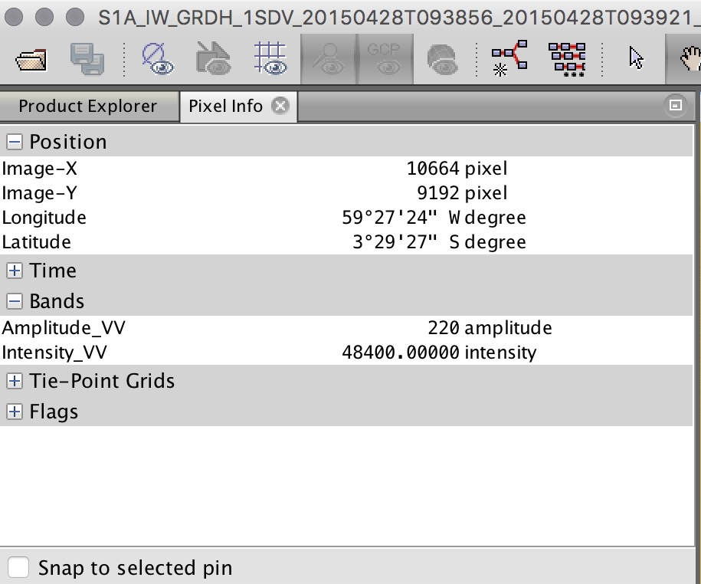In the lower, left-hand side, you can see in Worldview the coverage of the image selected. The image is inverted because it is oriented the same way it was acquired.
* In the upper left window, select **Pixel Info** to see the value and the latitude/longitude of each pixel in the open image
* Go back to the **Product Explorer** tab
* Select the file name of the Sentinel-1 dataset. Afterwards, select **Open RGB Image Window** to display a color image of VV, VH, and VV/VH ratio

## Part 3: Preprocessing

The objective is to subset the data and perform radiometric and geometric calibrations. This creates an image where the value of each pixel is directly related to the backscatter of the surface. This process is essential for analyzing the images in a quantitative way. It is also important for comparing images from different sensors, modalities, processors or acquired at different times.

* 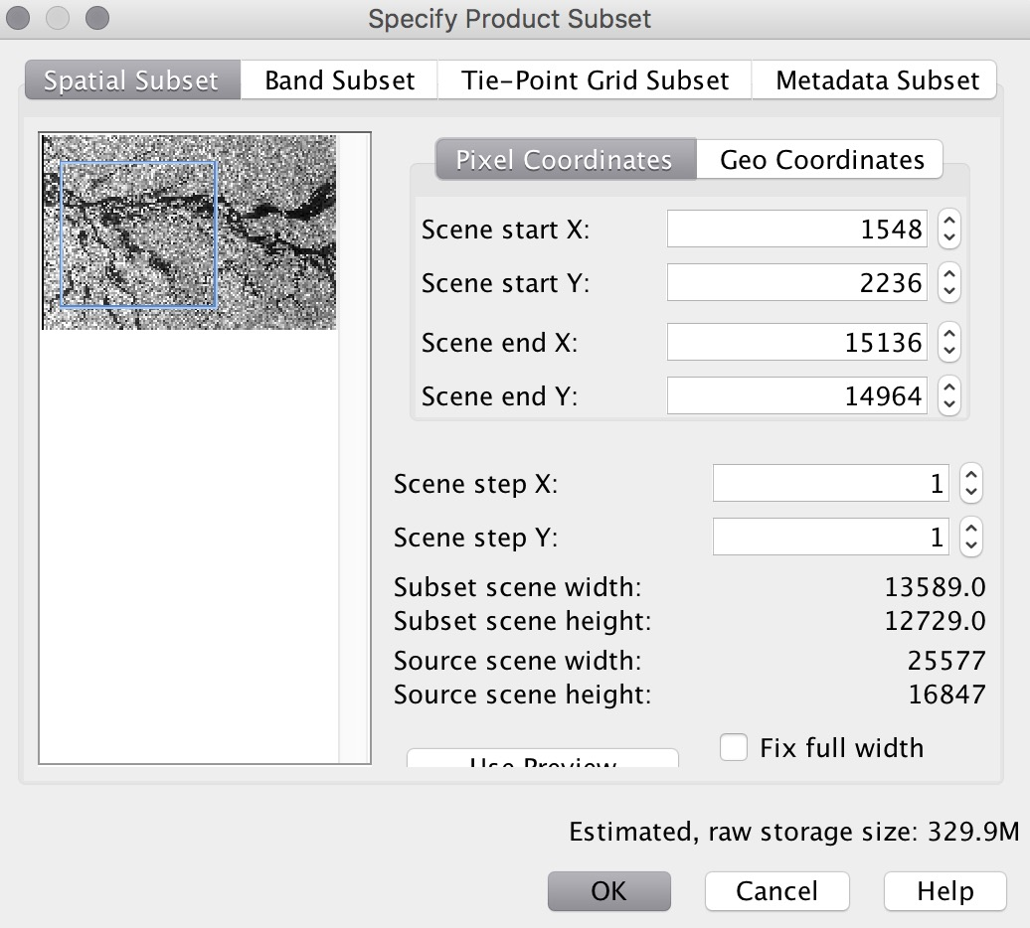Select **Raster** and then **Subset** according to the parameters below from this point on work only with the subset image
* Select **Radar** > **Radiometric** > **Calibrate** and use the default parameters
* Main radiometric distortions are due to:
  + Signal loss as it propagates
  + non-uniform antenna pattern
  + difference in gain
  + saturation
  + speckle
* Speckle Reduction: Speckle is part of radar images and makes interpretation difficult because the “salt and pepper” effect corrupts information about the surface
  + Speckle is part of radar images and makes interpretation difficult because the “salt and pepper” effect corrupts information about the surface
  + There are many techniques to extract information from radar images that will have lots of speckle
  + You can use speckle filters or Multilook the image. In this case, we will use the latter
* Select **Radar** > **Multilook**> then choose the Processing Parameters window and specify **6** for both number of range and azimuth looks 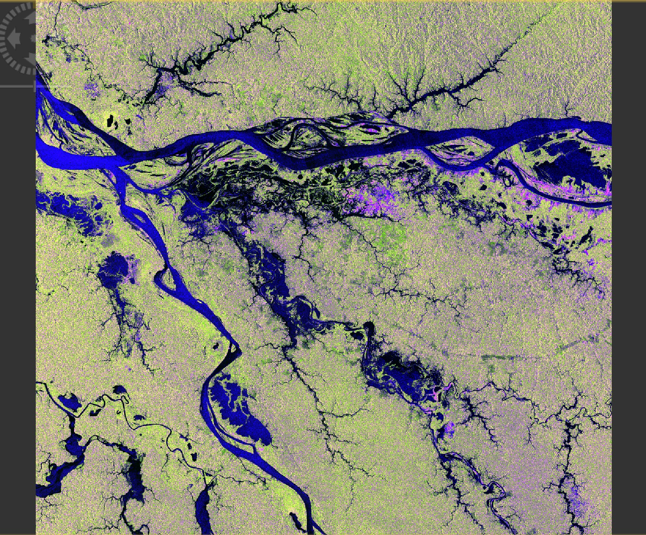
* Select **Radar** > **Geometric** > **Terrain Correction** > **Range-Doppler Terrain Correction**
  + The main geometric distortions are due to:
    - slant range
    - layover
    - shadow
    - foreshortening
  + The algorithm uses a DEM to make corrections
  + The corrected image is in its correct orientation
* 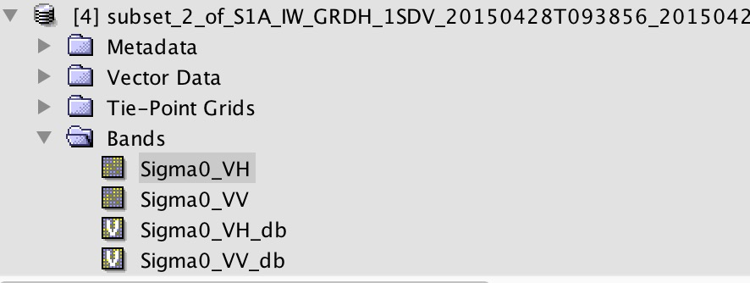Convert sigma0 into dB by highlighting Sigma0_VH and left clicking. A menu will pop up. Select **Linear to/from dB**

## Part 4: Analysis

**Histogram Analysis**

* Display the Sigma_VV_db image
* Analyze the image histogram in the lower left window
* Identify the two peaks: the lower one represents water and the higher one represents everything else
* 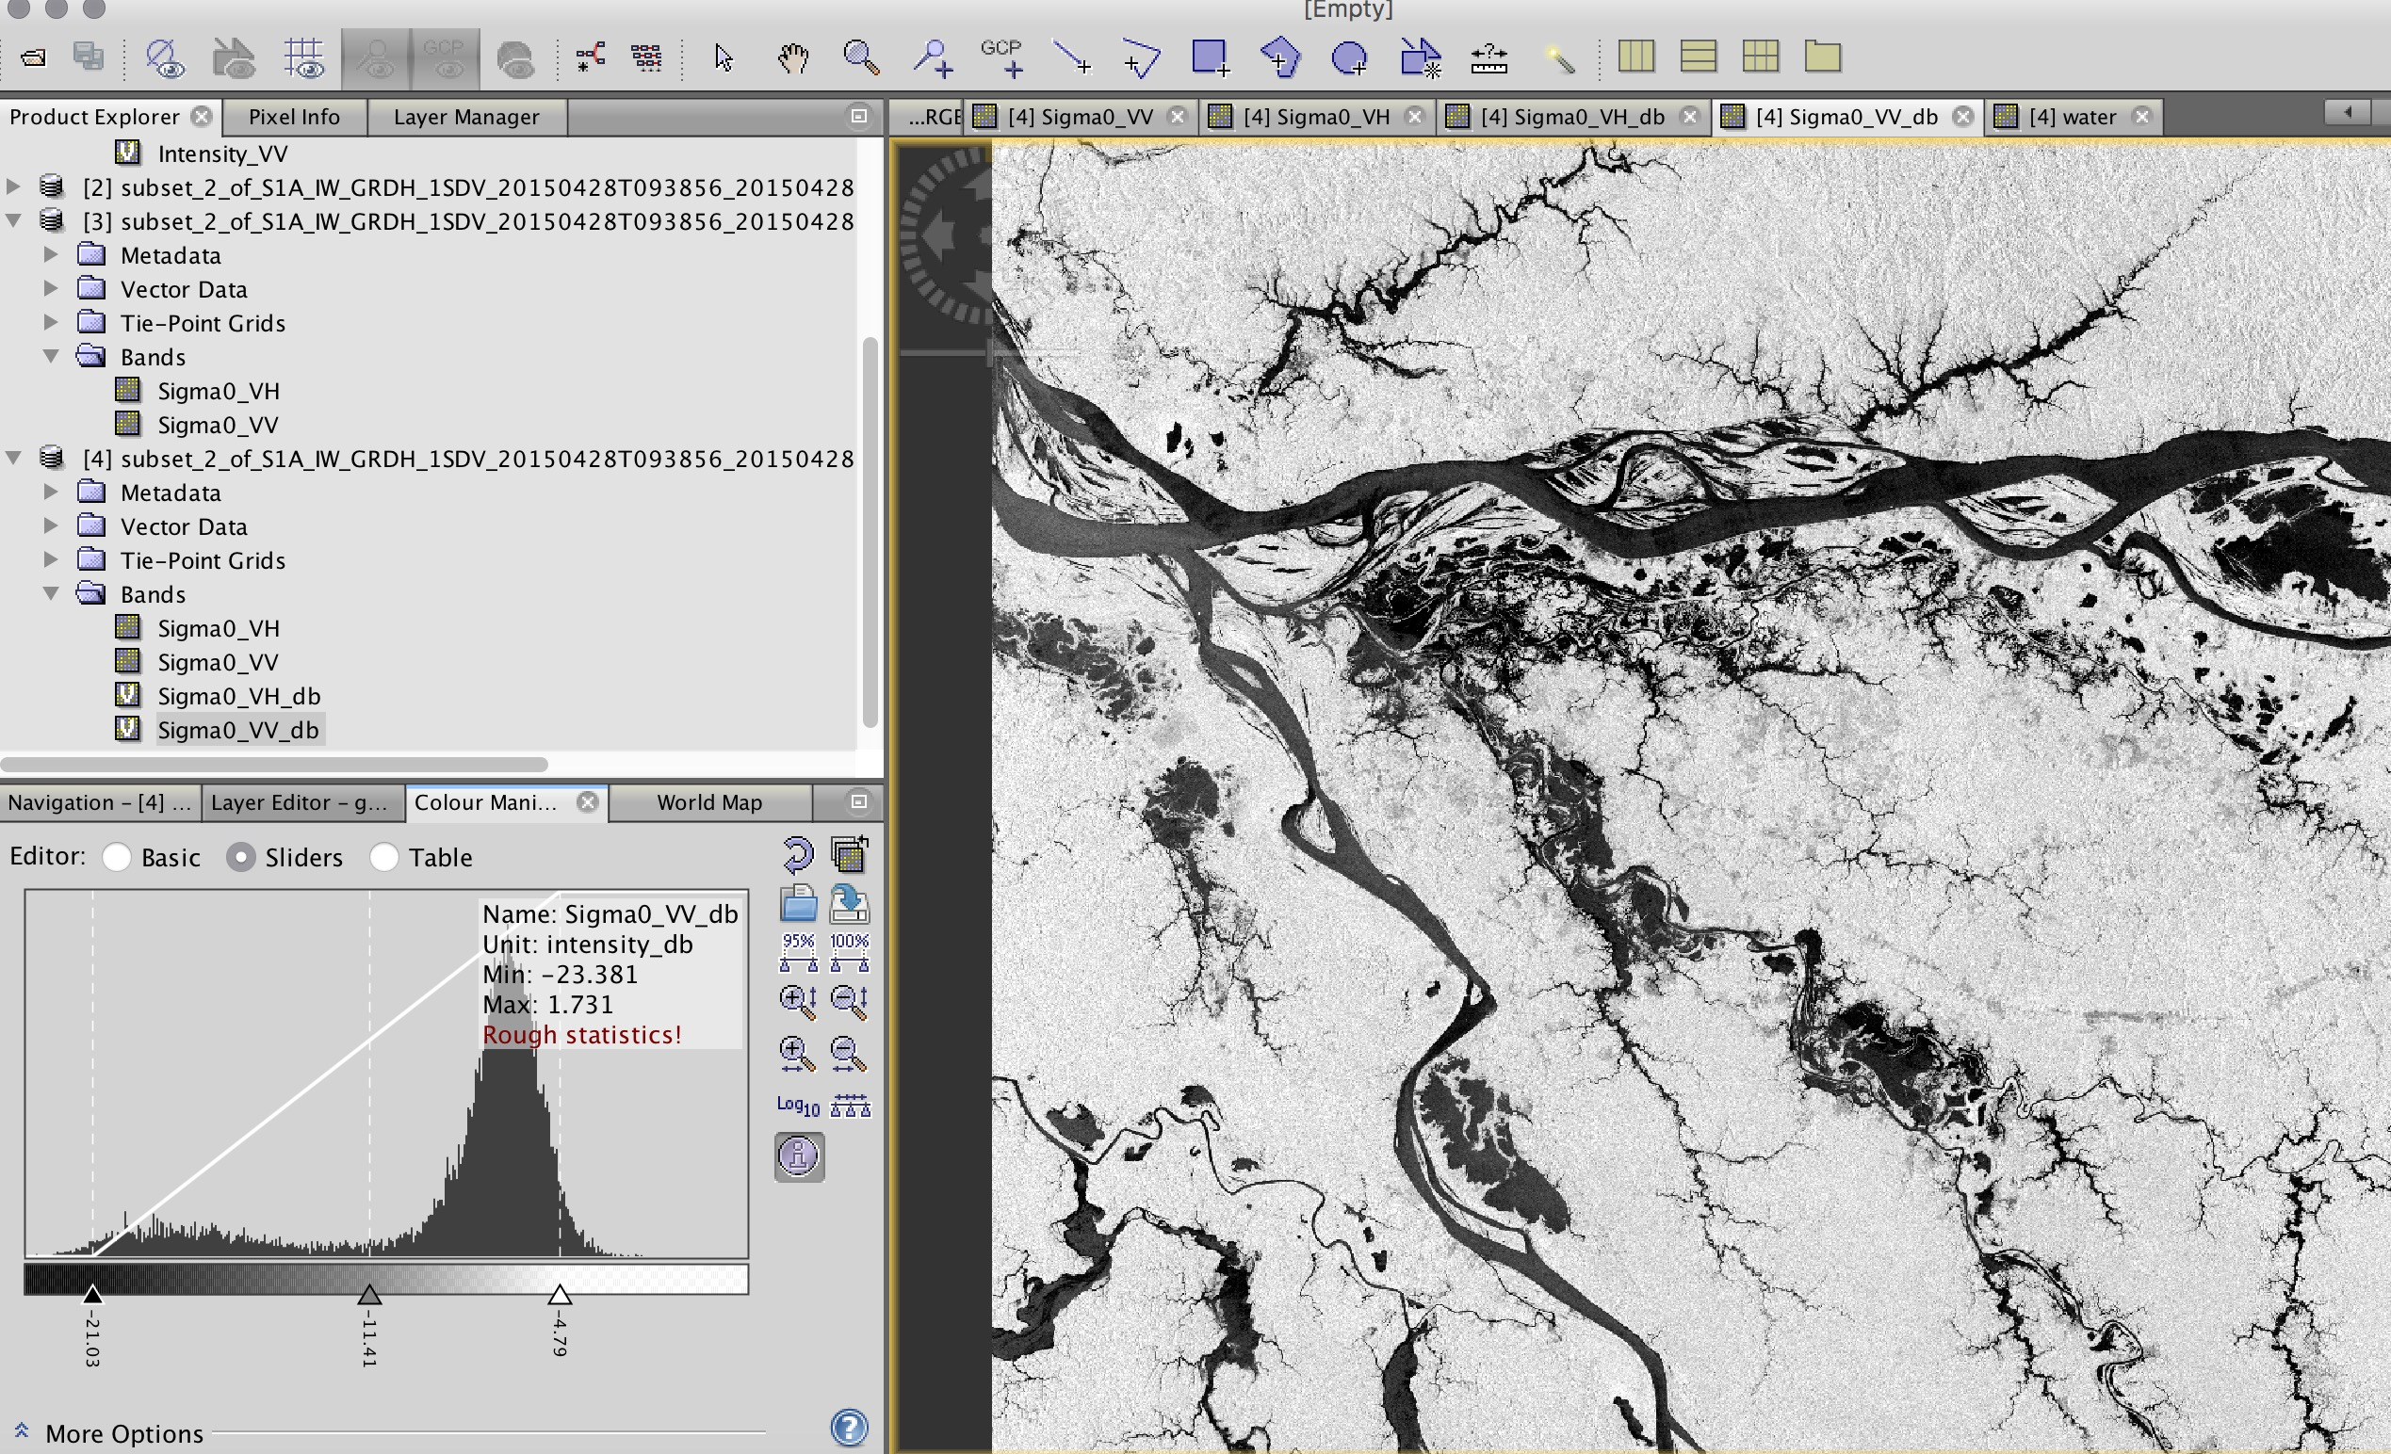Select the value that separates water from everything else. In this case, it’s **-11.4 dB**
* Select **Raster** > **Band** > **Math**
* To segment the image, apply band math
* Edit the expression so that it indicates: **255*(Sigma0_VV_db<-11.4)**
* The result will be an image where water will have a value of 255

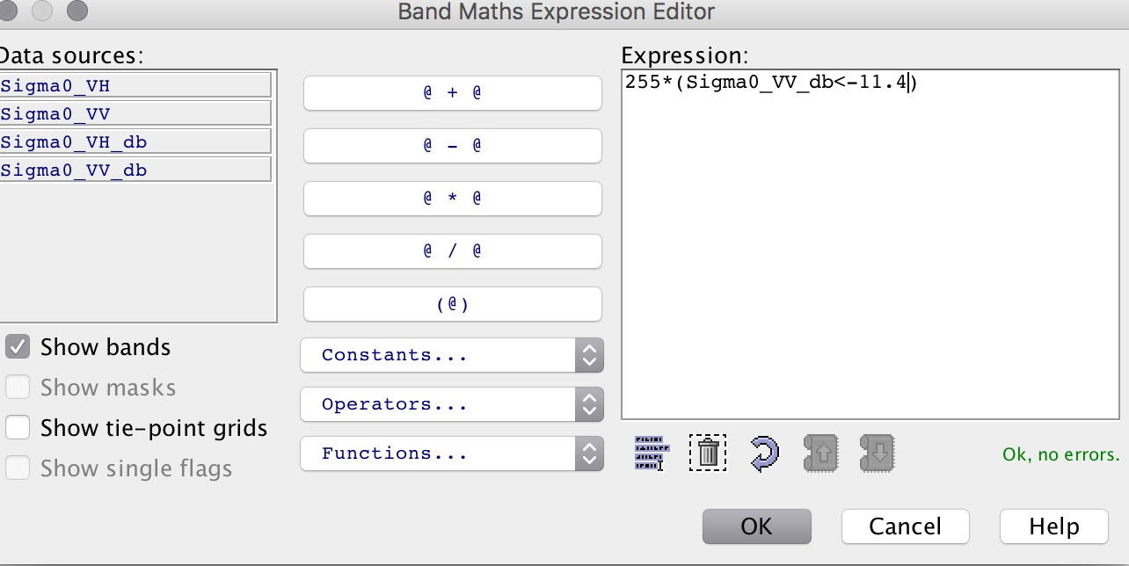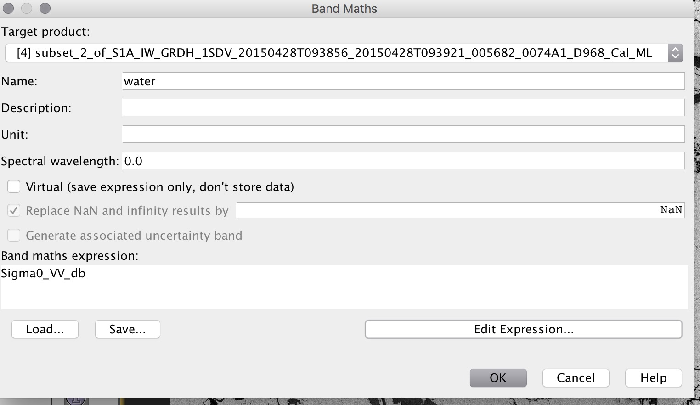

* 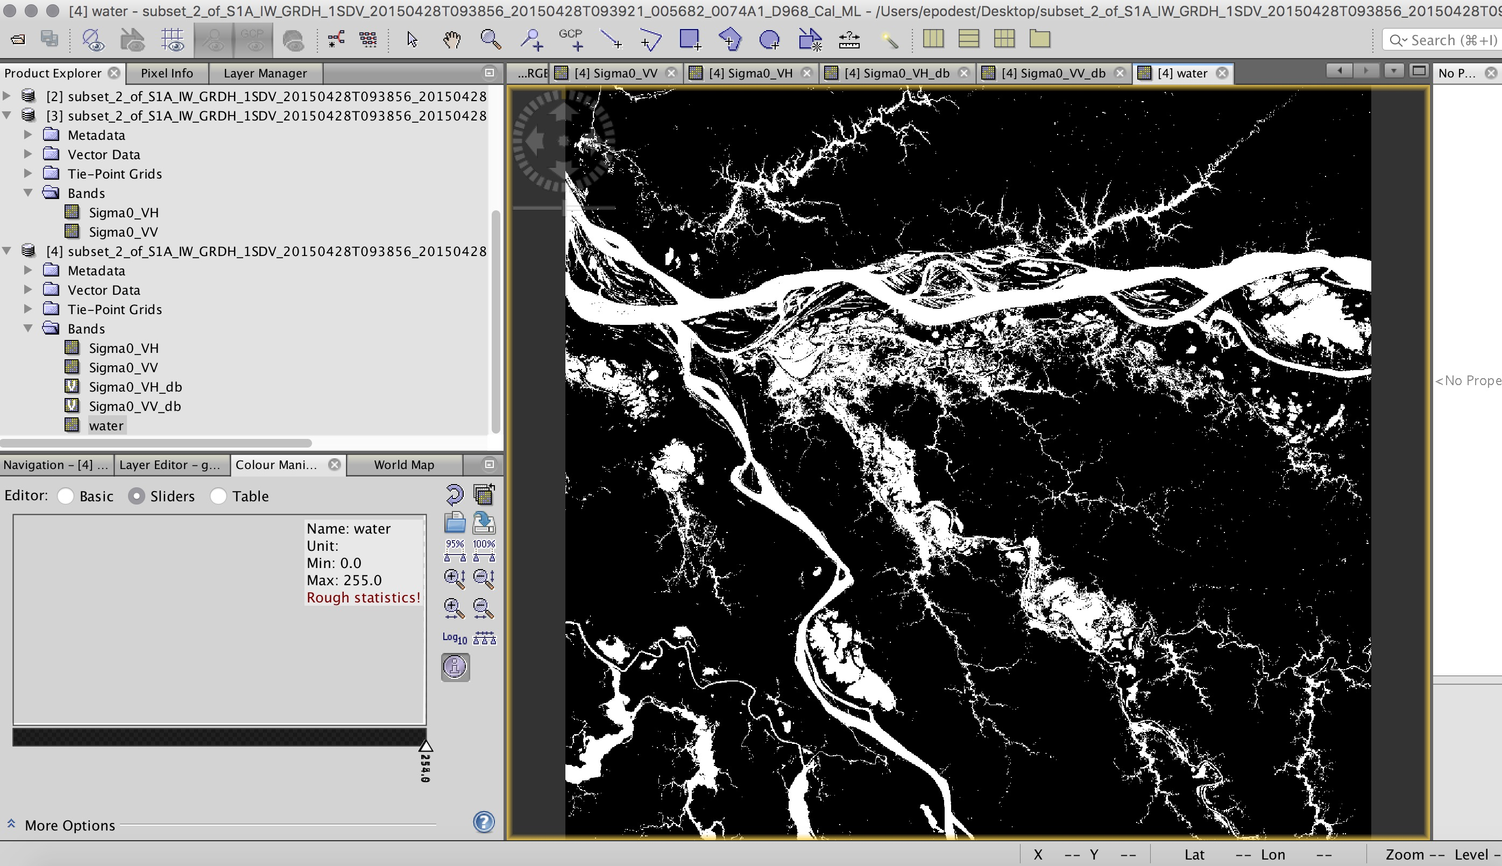To change the colors, go to the color manipulation window on the bottom left and select **Table**. There you can assign a color to each of the 3 classes.

